**Title of the Extended Abstract**

First Author, Second Author, Third Author

# Introduction

The introduction provides the background and rationale for the research, guiding readers from the broader context to the specific objectives of the study. It should begin with an overview of the topic, explaining its significance and relevance to current challenges or advancements. Highlight key findings or gaps from previous research to justify the study's importance. Clearly mention the research problem or gaps being addressed. Also, ensure the introduction is structured logically, moving from general to specific, and supported by relevant recent references.

Submission guidelines are given below,

* Extended abstracts should contain 1500-3000 words and at least **two** figures or tables.
* Extended abstracts should be formatted according to the given format. You may add or remove the headings and subheadings.
* Authors are advised not to change the given font type (Garamond), size (11.5), and line spacing (1.15).
* The work should not have been published elsewhere and should not be intended to be published elsewhere during the review period.
* The review process is Double-blind.
* All references including authors' previous work should be referred to as 3rd-persons' works.
* Manuscript submission should be in Adobe Portable Document Format (PDF) only. Once accepted, all Camera-Ready papers should be in the Microsoft Word format.
* Manuscripts that do not conform to the above formatting guidelines will not be considered.
* We request all authors to carefully revise the manuscript for English Language, similarity, and formatting.
* All submitted manuscripts will undergo a plagiarism check using Turnitin.
* Authors should send the author declaration form signed by all authors, after the notification of acceptance of the manuscript
* At least one author from each team must register with the conference in order to publish the paper/extended abstract.
* Typically, an extended abstract does not have a separate abstract because it itself serves as a detailed summary of the research. The extended abstract includes all the key components of a research paper (e.g., introduction, methods, results, discussion, and conclusion) in a condensed format.

# Experimental Section

The experimental section should provide enough detail to allow replication of the study. It should be concise yet sufficiently comprehensive, enabling other researchers to understand and reproduce your work.

## Materials

The Materials section should provide detailed information about all substances, components, and tools used in the study to ensure transparency and reproducibility.

If chemicals are used in the study, Authors should list all chemicals, reagents, and compounds used, specifying their chemical names, grades, purities, and suppliers.

## Methods

The Method section should describe the step-by-step process followed during the study in sufficient detail to allow other researchers to replicate the work. Authors are encouraged to visualize their methodology using a graphical figure.

## Materials Characterization

This section should provide details of the techniques used to test the properties of materials, including the equipment and methods employed, model and manufacturer, key operating parameters, sample preparation methods, calibration methods, and any deviations from standard protocols.

Information on software used for modelling and data analysis should also be included.

According to your study, you may rename these headings and subheadings.

# Results and Discussion

The results and discussion section should present the findings clearly, supported by tables, figures, or graphs, and interpret their significance. Summarize key results, and highlight trends or unexpected outcomes. Discuss the relevance of the findings, comparing them with previous studies. Address the implications, study limitations, and potential future directions. Ensure the analysis aligns with the study’s objectives and contributes to the broader scientific understanding.

## Figures

Figures should be of high resolution (at least 300 dpi) and clearly legible, with distinct lines, symbols, and text. Each figure should be numbered sequentially and include a concise title and detailed legend explaining all elements.

The choice between double-column (see **Figure 1**) or single-column (see **Figure 2**) figures depends on the type of data the authors want to present.

Use the “Breaks (continuous)” option in the “Layout” tab to navigate between single and double columns.

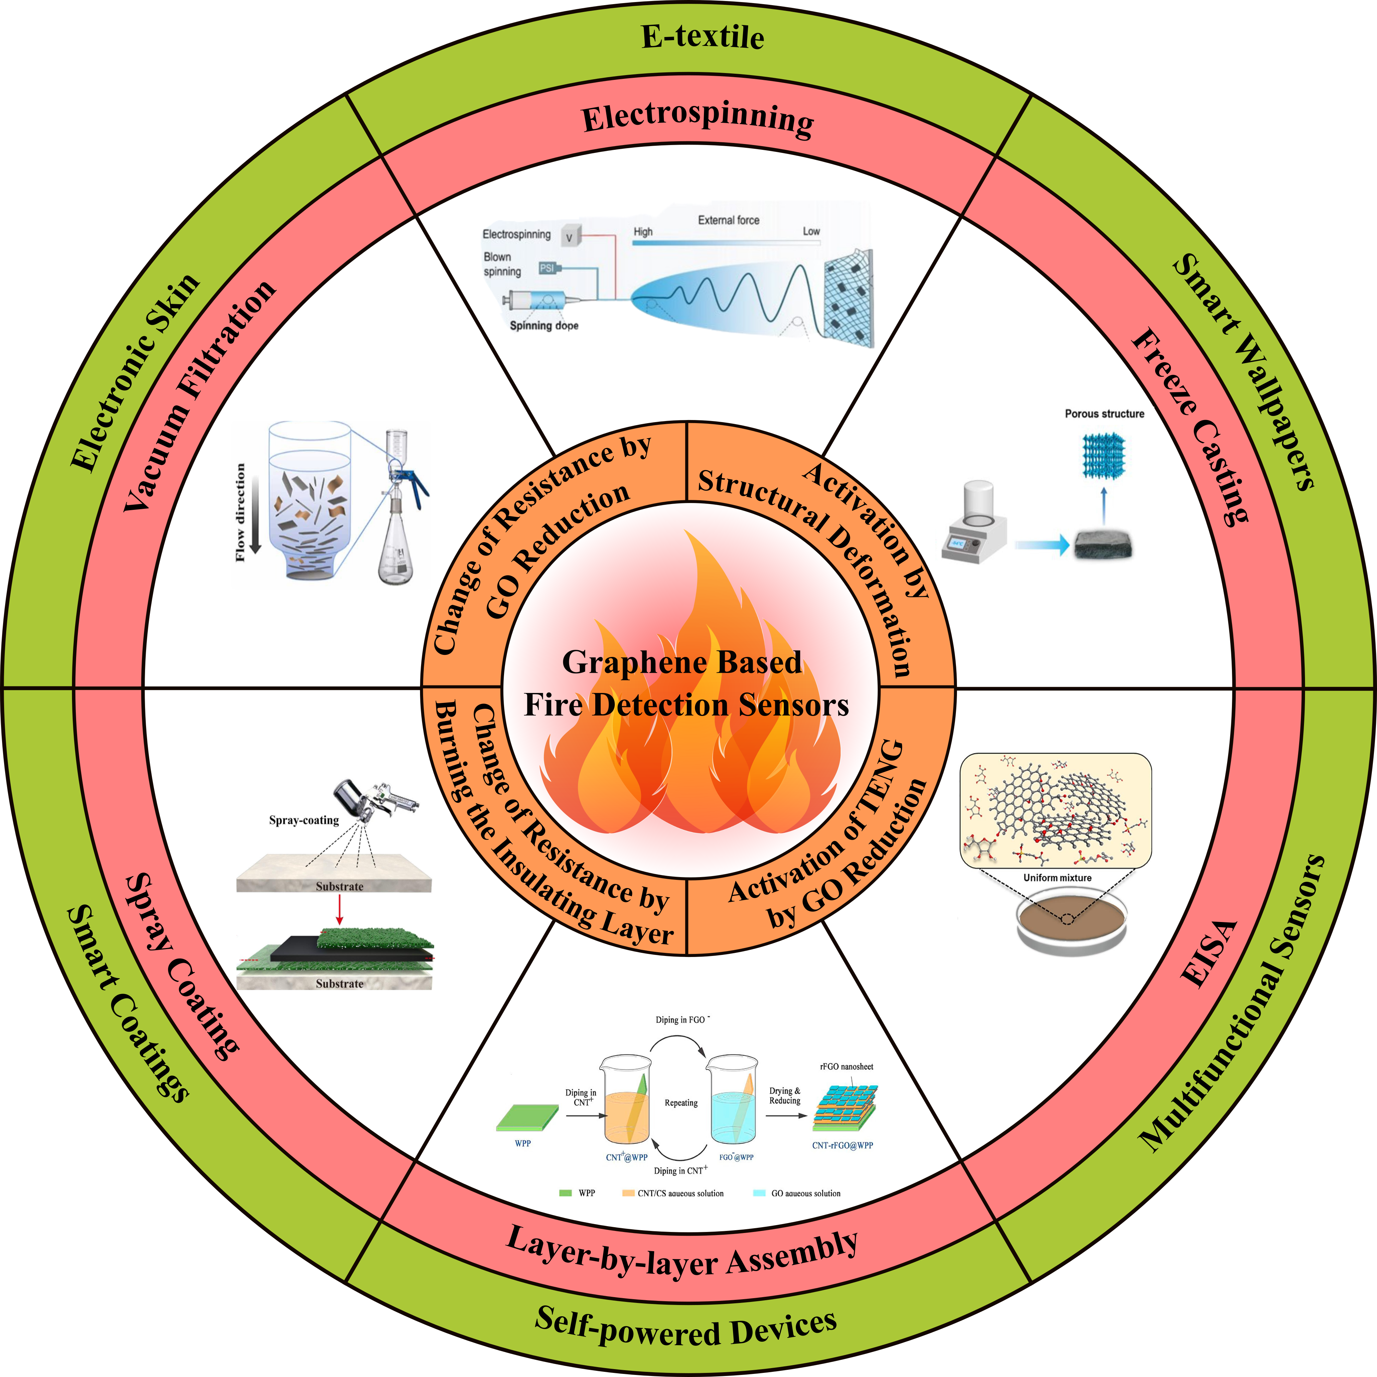

**Figure 1.** Double Column figure.

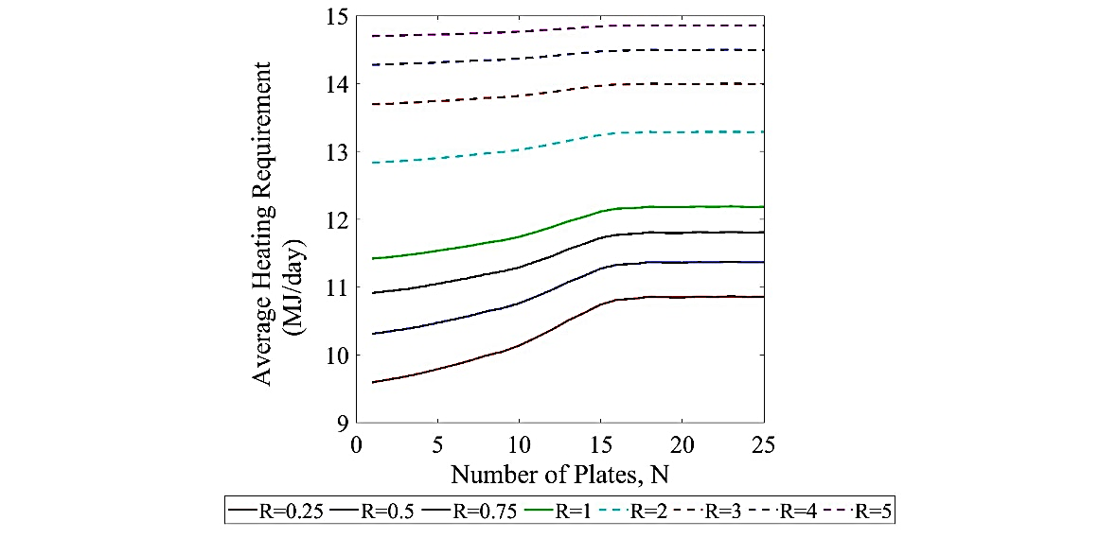

**Figure 2.** Single column figure.

Authors are encouraged to use advanced software to create publication-ready figures. For graphing and data visualization, tools such as GraphPad Prism, R (ggplot2), MATLAB, and OriginLab are recommended. For image editing and illustration, Adobe Illustrator, CorelDRAW, and the open-source alternative Inkscape are ideal. Drawing graphs using default Excel settings are not recommended.

## Tables

Tables should be numbered sequentially and include a clear, descriptive title placed above the table. Label all columns and rows, and specify units where applicable.

Tables should be self-explanatory, with enough detail for interpretation without referring to the main text, and should be referenced in the manuscript before they appear.

Tables can also be presented as single (see **Table 1**) or double column (see **Table 2**) layouts.

**Table 1.** Example of a table in a single column layout.

|  |  |  |
| --- | --- | --- |
| Column 1 | Column 2 | Column 3 |
| Data | Data | Data |
| Data | Data | Data |
| Data | Data | Data |
| Data | Data | Data |
|  |  |  |

**Table 2.** Example of a table in a double column layout.

|  |  |  |  |  |  |
| --- | --- | --- | --- | --- | --- |
| Column 1 | Column 2 | Column 3 | Column 4 | Column 5 | Column 6 |
| Data | Data | Data | Data | Data | Data |
| Data | Data | Data | Data | Data | Data |
| Data | Data | Data | Data | Data | Data |
| Data | Data | Data | Data | Data | Data |

## Equations

Equations should be numbered consecutively in parentheses (e.g., Eq. (1), Eq. (2)) and placed on a separate line for clarity. The equation number should be aligned to the right of the page. Use standard mathematical notation, and ensure all variables, constants, and coefficients are clearly defined in the text.

Eq. (1)

## Units

Authors must use SI (International System of Units) units throughout the manuscript for consistency and clarity.

# Conclusions

The Conclusions section should briefly summarize the key findings of the study, highlighting their significance and potential implications. It should provide a clear answer to the research question or objectives.

# Declaration of Competing Interest

Authors must disclose any potential conflicts of interest that could affect the research or its results, such as financial, personal, or professional relationships. If there are no conflicts, authors should state, “The authors declare no competing interests.”

# Acknowledgements

In the Acknowledgements section, recognize individuals, organizations, or institutions that helped with the research, such as funding sources, technical support, or resources.

# Author Information

Corresponding author: **Author name-1**, Affiliation, E-mail, ORCID ID (if available)

**Author name-2**, Affiliation, ORCID ID

**Author name-3**, Affiliation, ORCID ID

Example:

**Hiran Chathuranga**, Department of Chemical and Process Engineering, Faculty of Engineering, University of Moratuwa, Moratuwa, 10400, Sri Lanka. ORCID ID: <https://orcid.org/0000-0002-0906-0291>

# Credit Authorship Statement

The Credit Authorship Statement should clearly specify each author's contributions to the research and manuscript. This includes roles such as conceptualization, methodology, investigation, writing (original draft and review/editing), supervision, and funding acquisition. This statement ensures transparency and accurately acknowledges the contributions of each author involved in the project

Example:

**Author name-1**; Conceptualization, Data analysis, Visualization, Writing – original draft. **Author name-2**; Data analysis, Writing – review & editing. **Author** **name-3**; Supervision, Writing – review & editing.

Please note that it is mandatory to include details related to Declaration of competing interest and Credit Authorship.

# **Keywords**

Include four to six keywords.

# **Reference**s

For citations and referencing, please use a reference manager software; Mendeley is preferred.

Use the IEEE citation style.